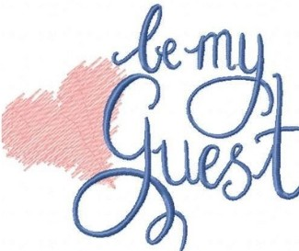

Thursday, May 19 Show Hours 10 am - 2 pm

Frederik Meijer Gardens & Sculpture Park
1000 East Beltline, NE • Grand Rapids, Ml 49525

We would like to invite you to attend the return of the incredible "Ideas in Bloom" Show returning to the fabulous and remodeled Frederik Meijer Gardens and Sculpture Park on Thursday, May 19. As our guest, you will receive entrance to both the Ideas in Bloom Show and to everything Meijer Gardens has to offer. Your name badge is your ticket.

On display you'll see fifty of our top promotional products and apparel suppliers showing off literally thousands of ways to build your brand and display your message. You'll see all of the latest colors, fashions, styles and trends.

In order to attend this industry show, you will need to be pre-registered which we can take care of for you. Just RSVP back to us and we’ll do the rest. You'll receive a confirmation email and a reminder a couple of times before the show.

Enjoy the Show! Let us know if you have any questions or need help with your registration.

Show Rules: This is an indoor show and will follow any safety mandates in place at the time of the show. The show aisles have been widened to assure greater social distancing and the show has been expanded to a second room as well.

Name Badge Pick-up: As you enter the show floor, the registration table will be just inside. Just tell the registration personnel your last name. Your badge will identify you as my guest.

How to Harvest All of the Ideas in Bloom! If you see items that you would like to have a quote, more information, a sample or a mock-up on, there are three ways to capture them to share with me.
1). Take a picture of the item with your phone. Just make sure that you also get a picture of the exhibitor's table so I can identify the items. 2). When you arrive, you will receive a show bag with lots of goodies including a journal book and pen. You can use these to capture your thoughts, ideas and brainstorms at the show for us to review later. Or,
3). You can request a clipboard and lead form from the registration table. The form is a three part form so you can keep one copy for you and one copy for me.

