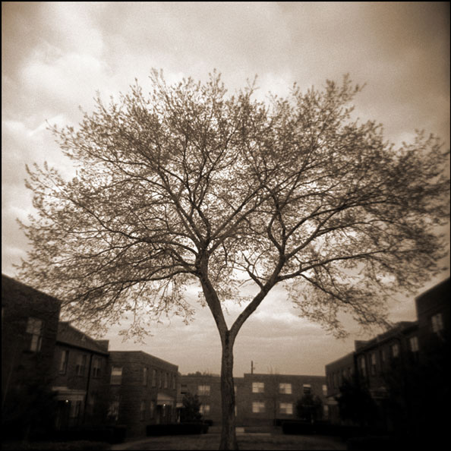

Be Our Guest!

Thursday, May 17, 2018

Frederik Meijer Gardens

1000 East Beltline NE

Grand Rapids, MI 49525

8:30 - 9:00 Badge Pick-up

9 am - 10 am: Continental & Keynote OR

Noon - 1 pm: Lunch & Learn

10 am - 2 pm: Free Exhibits of the the Best and Latest Trends in Promotional Marketing. 80 exhibits featuring thousands of ways to build your brand.

Be Our Guest!

Thursday, May 17, 2018

Frederik Meijer Gardens

1000 East Beltline NE

Grand Rapids, MI 49525

8:30 Badge Pick-up

9 am - 10 am: Continental & Keynote OR   
Noon - 1 pm: Lunch & Learn

10 am - 2 pm: Free Exhibits of the the Best and Latest Trends in Promotional Marketing. 80 exhibits featuring thousands of ways to build your brand.

Trenz Pruca

4321 First Street

Anytown, State ZIP

Be Our Guest at Ideas in Bloom!

Thursday, May 17, 2018

Frederik Meijer Gardens and Sculpture Park

1000 East Beltline NE

Grand Rapids, MI 49525

RSVP to register and attend this private event. You must be pre-registered.

Attendance at this event also includes

free admission to the Gardens and

Sculpture Park (a $14.50 value).

You’ll be amazed at all of the exciting promotion ideas blooming all around!

You **must pre-register** as a guest to attend this show.

Trenz Pruca

4321 First Street

Anytown, State ZIP

Be Our Guest at Ideas in Bloom!

Thursday, May 17, 2018

Frederik Meijer Gardens and Sculpture Park

1000 East Beltline NE

Grand Rapids, MI 49525

RSVP to register and attend this private event. You must be pre-registered.

Attendance at this event also includes

free admission to the Gardens and

Sculpture Park (a $14.50 value).

You’ll be amazed at all of the exciting promotion ideas blooming all around!

You **must pre-register** as a guest to attend this show.