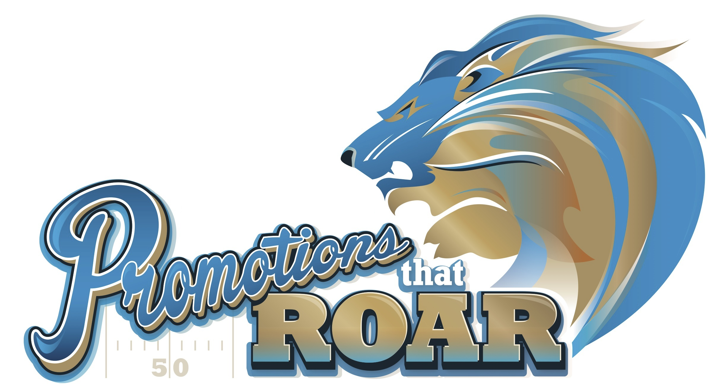
Please Be Our Guest
Wednesday, September 26
Ford Field — Home of the Detroit Lions
Free Parking and Entry at Gate G on St Antoine St, or
at Gate B in the Lions/Tigers Comerica Lot on Brush St.

Join us for a day of discovery, excitement and brand building experiences. See, touch and try thousands of promotional products including apparel, awards, business accessories, bags, drinkware, tech items and writing instruments. Find out what’s hot, what’s trending and find the next big thing.

Free continental breakfast starting at 9:15 am in the
Hall of Legends where you’ll hear the CEO and President of the Promotional Products Association International (PPAI), Paul Bellantone present “The Power of Promotional Products To Create Amazing Results”

120 Exhibit Booths on Display from 11:00 am - 3:00 pm
Free VIP Stadium Tours
RSVP Today to Receive Your Free Parking Pass and Badge Credentials.
Free Swag Bag, Photo Keepsake and much more.
Appearances by Roary, the Lions Mascot and the chance to attempt to kick a field goal on the playing field!
Admission by Invitation Only.

RSVP Today!

