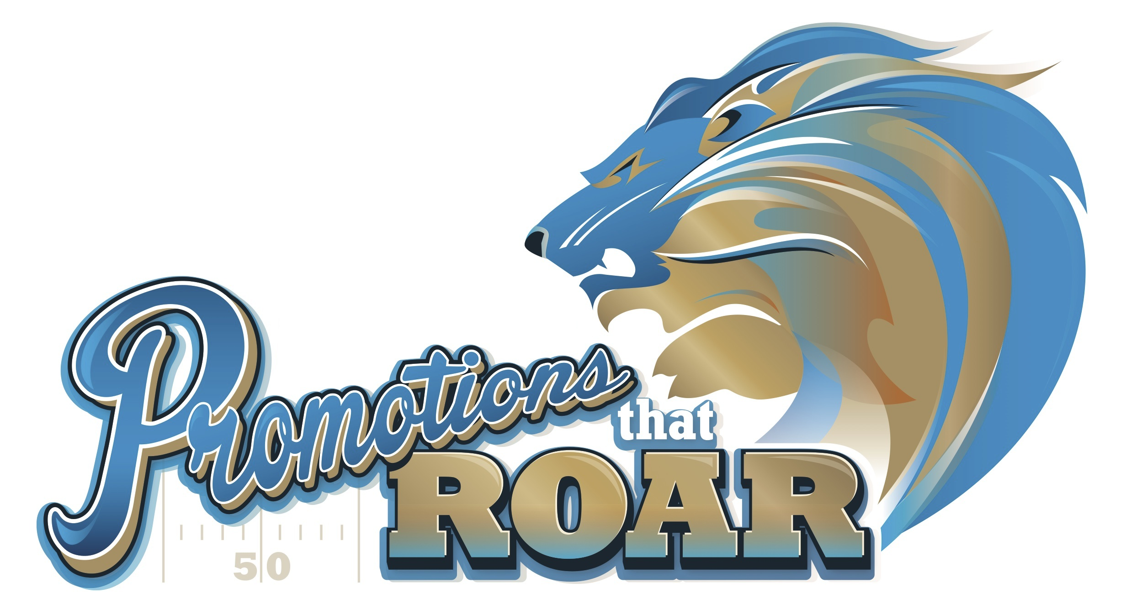

Save The Date

Be Our Guest

**The Biggest, Most Exciting Promotional Marketing Show**

Wednesday, September 25, 2019

Ford Field - Home of the Detroit Lions

By invitation only. RSVP today so we can register you and get your parking pass and show credentials.

Wednesday, September 25

9:15 am: Free Continental Breakfast in the Hall of Legends

9:30 am: Free Keynote featuring Bill Petrie, President of PromoCorner on “Creating a Culture of WOW!

11:00 am - 3:00 pm: Promotions That ROAR! Exhibits Open

As our guest, you’ll receive free parking in either the Ford Field Ramp at Gate G, or in the Tigers Garage at Gate B, free admission to the show, free keynote and continental breakfast, free swag bag, free photo souvenir, free VIP Stadium Tour, and the chance to attempt to kick a field goal on the playing field!