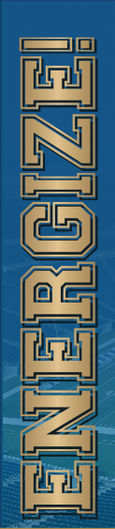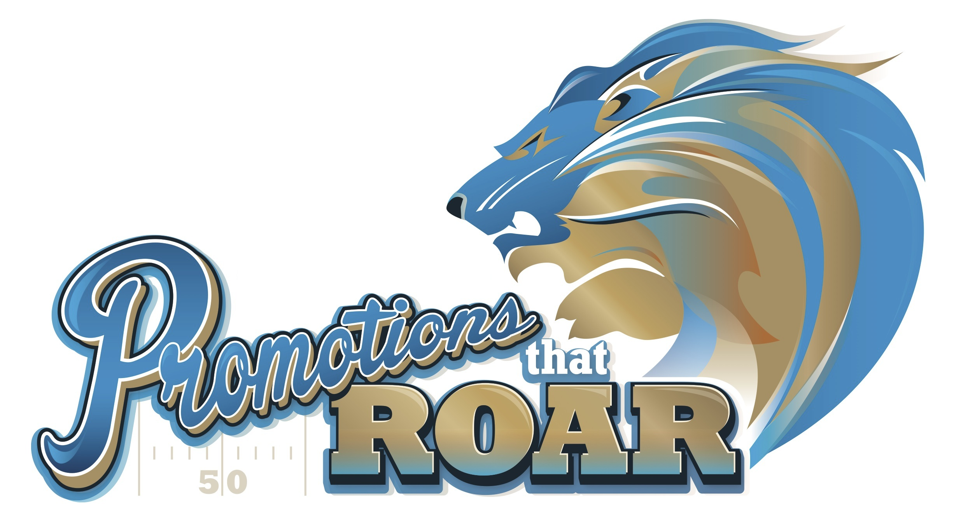

Save The Date! Be Our Guest!

Biggest Promotional Marketing Show

September 27, 2017 - Ford Field

Save The Date! Be Our Guest!

Biggest Promotional Marketing Show

September 27, 2017 - Ford Field

Promotions That ROAR!

Save the Date! and Be Our Guest!

September 27, 2017

Ford Field - Home of the Detroit Lions

By invitation only. RSVP Today so we can register you and get your parking pass and ticket.

Wednesday, September 27

9:15 am: Free Continental Breakfast

9:45 am: Free Keynote: “Energize! Connect and

Build to Create Ridiculous Results!”

11:00 am - 3:00 pm: Promotions That ROAR!

Exhibits Open - The BEST of Promotion Marketing on Display!

As our guest, you’ll receive Free Parking in the Ford Field Parking Ramp, Free Admission, Free Keynote presentation by one of the top digital marketers in the country, free Swag Bag, free Green Screen photo souvenir, free VIP Stadium Tour and much more!

Promotions That ROAR!

Save the Date! and Be Our Guest!

September 27, 2017

Ford Field - Home of the Detroit Lions

By invitation only. RSVP Today so we can register you and get your parking pass and ticket.

Wednesday, September 27

9:15 am: Free Continental Breakfast

9:45 am: Free Keynote: “Energize! Connect and

Build to Create Ridiculous Results!”

11:00 am - 3:00 pm: Promotions That ROAR!

Exhibits Open - The BEST of Promotion Marketing on Display!

As our guest, you’ll receive Free Parking in the Ford Field Parking Ramp, Free Admission, Free Keynote presentation by one of the top digital marketers in the country, free Swag Bag, free Green Screen photo souvenir, free VIP Stadium Tour and much more!