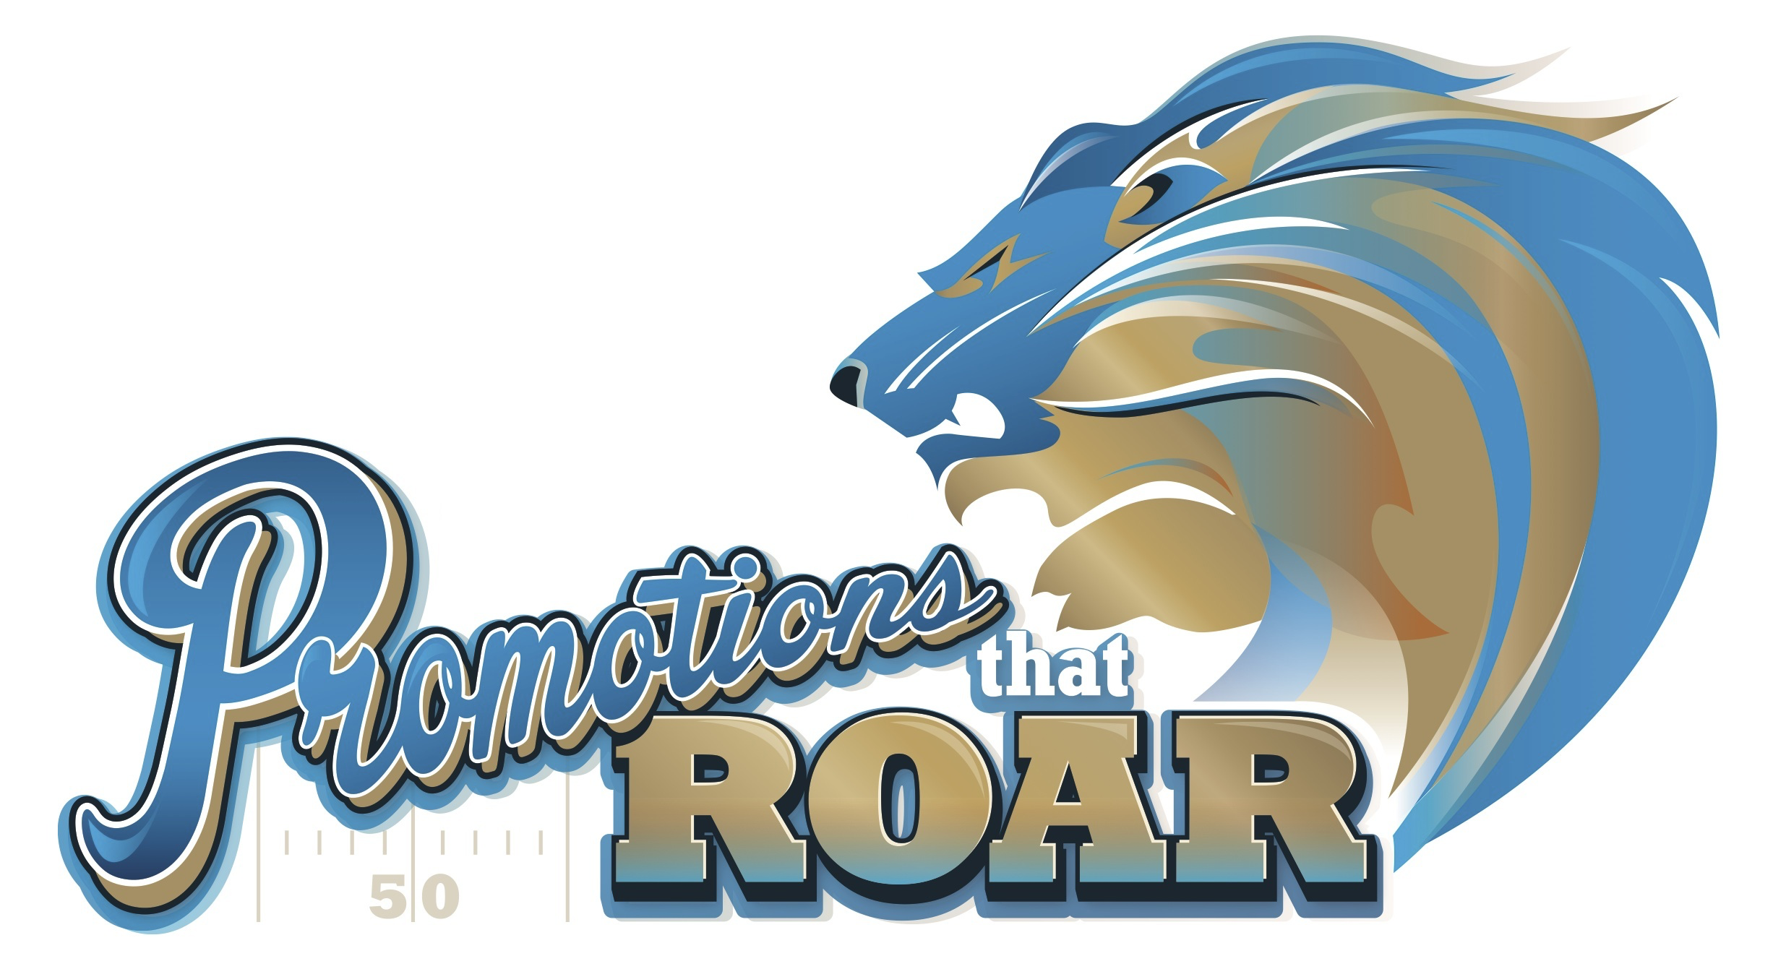
We would like for you to be our guest at the biggest Promotional Products Show in Michigan.
Be Our Guest
Wednesday, September 21, 2022
11:00 am - 3:00 pm
Ford Field - Home of the Detroit Lions

You'll see, hear and touch the hottest new ideas in branded merchandise and experience the thrill of the sensory media. Free parking. Free bag of samples. Free VIP Stadium Tour, Free on-field kicking experience.
By invitation only. RSVP to me today!

In order to attend this promotion industry show, you will need to be pre-registered which we can take care of for you. Just RSVP back to us and we’ll do the rest. You’ll receive a confirmation email and a reminder a couple of times before the show. You’ll also receive the code for free parking right next to Ford field.

Show Rules: This is an indoor show and will follow any safety mandates in place at the time of the show. Ford Field does have metal detectors that you must pass through to enter the building.

Name Badge Pick-Up: Your registration confirmation will have a bar code which you can scan in the registration area to generate your own badge or you can stop at the registration desk to pick it up.

How to Get The Most from the Show Experience: Plan on taking it all in. You can take a VIP Stadium Tour, attempt to kick a field goal on the playing field, pet puppies and you’ll see hundreds of exhibitors, thousands of product and generate a million and one ideas.
You’ll see lots of items that you’ll want us to get you more info about, maybe a sample or a quote. The best ways to capture them to share with us are…
- Take a picture of the item with your phone. Just make sure you also get a picture of the exhibitor’s booth so we can identify it.
- When you arrive, you’ll receive a show bag with lots of goodies including a journal book and pen. You can use these to capture your thoughts, ideas and brainstorms at the show to review with us later.

